BANK LOAN REPORT QUERY DOCUMEN
/*FETCH ALL DATA FROM TABLE BANK LOAN ANALYSIS*/
SELECT * FROM BANK_LOAN_DATA;

/*FIND TOTAL LOAN APPLICATION*/
SELECT
COUNT(ID)AS TOTAL_LOAN_APPLICATION
FROM BANK_LOAN_DATA;
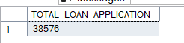

/*FIND MTD LOAN APPLICATIONS*/
SELECT
COUNT(ID) AS MTD_LOAN_APPLICATION
FROM BANK_LOAN_DATA
WHERE MONTH(Issue_Date)='12'
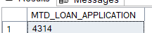

/*FIND PMTD LOAN APPLICATIONS */
SELECT
COUNT(ID)AS PMTD_LOAN_APPLICATION
FROM BANK_LOAN_DATA
WHERE MONTH(issue_date)='11';
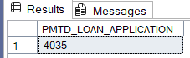

/*FIND TOTAL FUNDED AMOUNT*/
SELECT
SUM(loan_amount) AS TOTAL_FUNDED_AMOUNT
FROM BANK_LOAN_DATA;
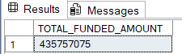

/*FIND TOTAL FUNDED AMOUNT FOR MONTH 12 OF YEAR 2021 MTD*/
SELECT
SUM(loan_amount)AS 'TOTAL FUNDE DAMOUNT'
FROM BANK_LOAN_DATA
WHERE MONTH(issue_date)='12'AND YEAR(issue_date)=2021;
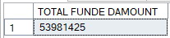

/*FIND TOTAL FUNDED AMOUNT FOR MONTH 11 F YEAR 2021 PMTD*/
SELECT
SUM(loan_amount)AS 'TOTAL FUNDED AMOUNT'
FROM BANK_LOAN_DATA
WHERE MONTH(issue_date)='11'AND YEAR(issue_date)=2021;
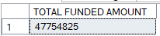

/*FIND TOTAL AMOUNT RECEIVED*/
SELECT
SUM(total_payment)AS 'AMOUNT RECEIVED'
FROM BANK_LOAN_DATA;
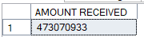

/*FIND MTD TOTAL AMOUNT RECEIVED*/
SELECT
SUM(total_payment)AS 'MTD AMOUNT RECEIVED'
FROM BANK_LOAN_DATA
WHERE MONTH(issue_date)='12'AND YEAR(issue_date)=2021;
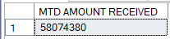

/*FIND PMTD AMOUNT RECEIVED*/
SELECT
SUM(total_payment)AS 'PMTD AMOUNT RECEIVED'
FROM BANK_LOAN_DATA
WHERE MONTH(issue_date)='11'AND YEAR(issue_date)=2021;
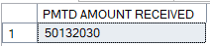

/*FIND AVERAGE INTEREST RATE*/
SELECT
CAST(AVG(int_rate)*100 AS DECIMAL(10,2))AS 'AVG INTEREST RATE'
FROM BANK_LOAN_DATA;

SELECT
ROUND(AVG(int_rate),4)*100 AS 'AVG INTEREST RATE'
FROM BANK_LOAN_DATA;
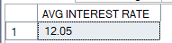

/*FIND MTD AVERAGE INTEREST RATE*/
SELECT
AVG(int_rate)*100 AS 'MTD AVG INTEREST RATE'
FROM BANK_LOAN_DATA
WHERE MONTH(issue_date)='12'AND YEAR(issue_date)=2021;
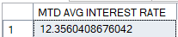

/*FIND PMTD AVERAGE INTEREST RATE*/
SELECT
AVG(int_rate)*100 AS 'PMTD AVG INTEREST RATE'
FROM BANK_LOAN_DATA
WHERE MONTH(issue_date)='11' AND YEAR(issue_date)=2021;
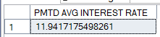

/* FIND AVERAGE DTI (DEBT-TO-INCOME)*/
SELECT
CAST(AVG(dti)*100 AS DECIMAL(10,2))AS 'AVG DTI'
FROM BANK_LOAN_DATA;

SELECT
ROUND(AVG(dti),4*100)AS 'AVG DTI'
FROM BANK_LOAN_DATA;
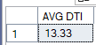

/* FIND mtd AVERAGE DTI (DEBT-TO-INCOME)*/
SELECT
CAST(AVG(dti)*100AS DECIMAL(10,2))AS 'AVG DTI'
FROM BANK_LOAN_DATA
WHERE MONTH(issue_date)='12';
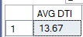

/* FIND PMTD AVERAGE DTI (DEBT-TO-INCOME)*/
SELECT
CAST(AVG(dti)*100AS DECIMAL(10,2))AS 'AVG DTI'
FROM BANK_LOAN_DATA
WHERE MONTH(issue_date)='11';
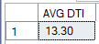

/*FIND NUMBER OF GOOD LOAN APPLICATIONS*/
SELECT
COUNT(ID)AS 'GOOD LOAN APPLICATIONS'
FROM BANK_LOAN_DATA
WHERE loan_status IN('FULLY PAID','CURRENT');
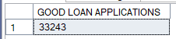

/*FIND GOOD LOAN FUNDED AMOUNT*/
SELECT
SUM(loan_amount)AS 'FUNDED AMOUNT'
FROM BANK_LOAN_DATA
WHERE loan_status IN('CURRENT','FULLY PAID');
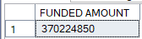

/*FIND GOOD LOAN AMOUNT RECEIVED*/
SELECT
SUM(total_payment)AS 'AMOUNT RECEIVED'
FROM BANK_LOAN_DATA
WHERE loan_status IN('CURRENT','FULLY PAID');
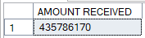

/*FIND GOOD LOAN PERCENTAGE*/
SELECT
(COUNT(CASE WHEN loan_status IN('FULLY PAID','CURRENT')THEN ID END)*100)
/
COUNT(ID)AS GOOD_LOAN_PERCENTAGE
FROM BANK_LOAN_DATA
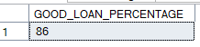

/*FIND BAD LOAN APPLICATIONS*/
SELECT
COUNT(ID) AS 'BAD LOAN APPLICATION'
FROM BANK_LOAN_DATA
WHERE loan_status='CHARGED OFF';
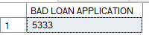

/*BAD LOAN FUNDED AMOUNT*/
SELECT
SUM(loan_amount)AS 'BAD LOAN FUNDED AMOUNT'
FROM BANK_LOAN_DATA
WHERE loan_status='CHARGED OFF';
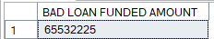

/*BAD LOAN AMOUNT RECEIVED*/
SELECT
SUM(total_payment)AS 'BAD LOAN AMOUNT RECEIVED'
FROM BANK_LOAN_DATA
WHERE loan_status='CHARGED OFF';
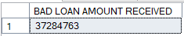

/*FIND BAD LOAN PERCENTAGE*/
SELECT
(COUNT(CASE WHEN loan_status='CHARGED OFF' THEN ID END)*100.0)
/
COUNT(ID) AS 'BAD LOAN PERCENTAGE'
FROM BANK_LOAN_DATA;
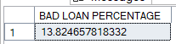

/*LOAN STATUS GRID VIEW*/
SELECT
loan_status,
COUNT(ID) AS 'TOTAL LOAN APPLICATIONS',
SUM(total_payment)AS 'TOTAL AMOUNT RECEIVED',
SUM(loan_amount) AS 'TOTAL FUNDED AMOUNT',
AVG(int_rate * 100) AS 'AVG INTEREST RATE',
AVG(DTI *100) AS 'AVG DTI'
FROM BANK_LOAN_DATA
GROUP BY loan_status;
/*MTD FUNDED AMOUNT AND MTD RECEIVED AMOUNT ACCORDING TO LOAN STATUS*/
SELECT
loan_status,
SUM(loan_amount) AS 'MTD FUMDED AMOUNT',
SUM(total_payment) AS 'MTD RECEIVED AMOUNT'
FROM BANK_LOAN_DATA
WHERE MONTH(issue_date)='12'
GROUP BY loan_status;
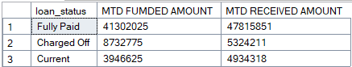

/*MONTHLY TRENDA BY ISSUE DATE (TOTAL LOAN APPLICATIONS,TOTAL FUNDED AMOUNT, TOTAL RECEIVED AMOUT)*/
SELECT
MONTH(issue_date) AS 'MONTH NUMBER',
DATENAME(MONTH,issue_date) AS 'MONTH' ,
COUNT(ID) AS 'TOTAL LOAN APPLICATIONS',
SUM(loan_amount) AS 'TOTAL FUNDED AMOUNT',
SUM(total_payment) AS 'TOTAL RECEIVED AMOUNT'
FROM BANK_LOAN_DATA
GROUP BY MONTH(issue_date),DATENAME(MONTH,issue_date)
ORDER BY MONTH(issue_date);
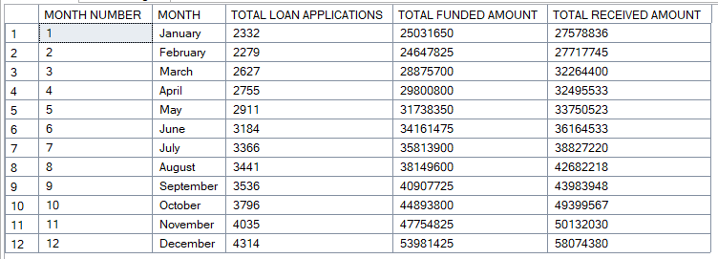

/*REGIONAL ANALYSIS BY STATE (TOTAL LOAN APPLICATIONS,TOTAL FUNDED AMOUNT, TOTAL RECEIVED AMOUT)*/
SELECT
address_state,
COUNT(ID)AS 'TOTAL LOAN APPLICATIONS',
SUM(loan_amount)AS 'TOTAL FUNDED AMOUNT',
SUM(total_payment)AS 'TOTAL RECEIVED AMOUNT'
FROM BANK_LOAN_DATA
GROUP BY address_state
ORDER BY 'TOTAL LOAN APPLICATIONS'DESC;
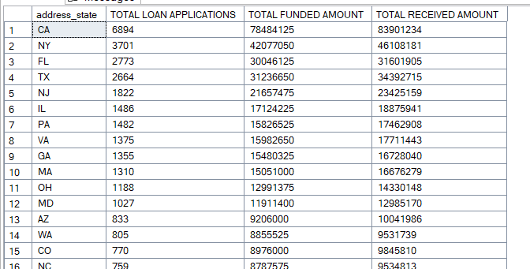

/*LOAN TERM ANALYSIS (TOTAL LOAN APPLICATIONS,TOTAL FUNDED AMOUNT, TOTAL RECEIVED AMOUT)*/
SELECT
term,
COUNT(ID)AS 'TOTAL LOAN APPLICATIONS',
SUM(loan_amount)AS 'TOTAL FUNDED AMOUNT',
SUM(total_payment)AS 'TOTAL RECEIVED AMOUNT'
FROM BANK_LOAN_DATA
GROUP BY term
ORDER BY term;
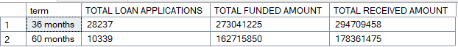

/*EMPLOYEE LENGTH ANALYSIS (TOTAL LOAN APPLICATIONS,TOTAL FUNDED AMOUNT, TOTAL RECEIVED AMOUT)*/
SELECT
emp_length,
COUNT(ID)AS 'TOTAL LOAN APPLICATIONS',
SUM(loan_amount)AS 'TOTAL FUNDED AMOUNT',
SUM(total_payment)AS 'TOTAL RECEIVED AMOUNT'
FROM BANK_LOAN_DATA
GROUP BY emp_length
ORDER BY emp_length;
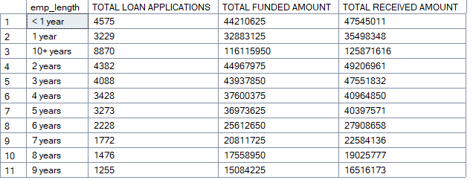

/*LOAN PURPOSE BREAKDOWN (TOTAL LOAN APPLICATIONS,TOTAL FUNDED AMOUNT, TOTAL RECEIVED AMOUT)*/
SELECT
purpose,
COUNT(ID)AS 'TOTAL LOAN APPLICATIONS',
SUM(loan_amount)AS 'TOTAL FUNDED AMOUNT',
SUM(total_payment)AS 'TOTAL RECEIVED AMOUNT'
FROM BANK_LOAN_DATA
GROUP BY purpose
ORDER BY 'TOTAL LOAN APPLICATIONS' DESC;
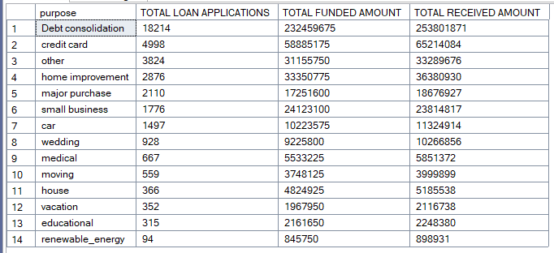

/*HOME OWNERSHIP ANALYSIS(TOTAL LOAN APPLICATIONS,TOTAL FUNDED AMOUNT, TOTAL RECEIVED AMOUT)*/
SELECT
home_ownership,
COUNT(ID)AS 'TOTAL LOAN APPLICATIONS',
SUM(loan_amount)AS 'TOTAL FUNDED AMOUNT',
SUM(total_payment)AS 'TOTAL RECEIVED AMOUNT'
FROM BANK_LOAN_DATA
GROUP BY home_ownership
ORDER BY 'TOTAL LOAN APPLICATIONS' DESC;

